Ideation Phase
Brainstorm & Idea Prioritization
Date | 03 October 2026
Developer | Vinay Krishna A K
Project Name | Automated Network Request Management in ServiceNow

Step-1: Problem Statement & Solution Scope

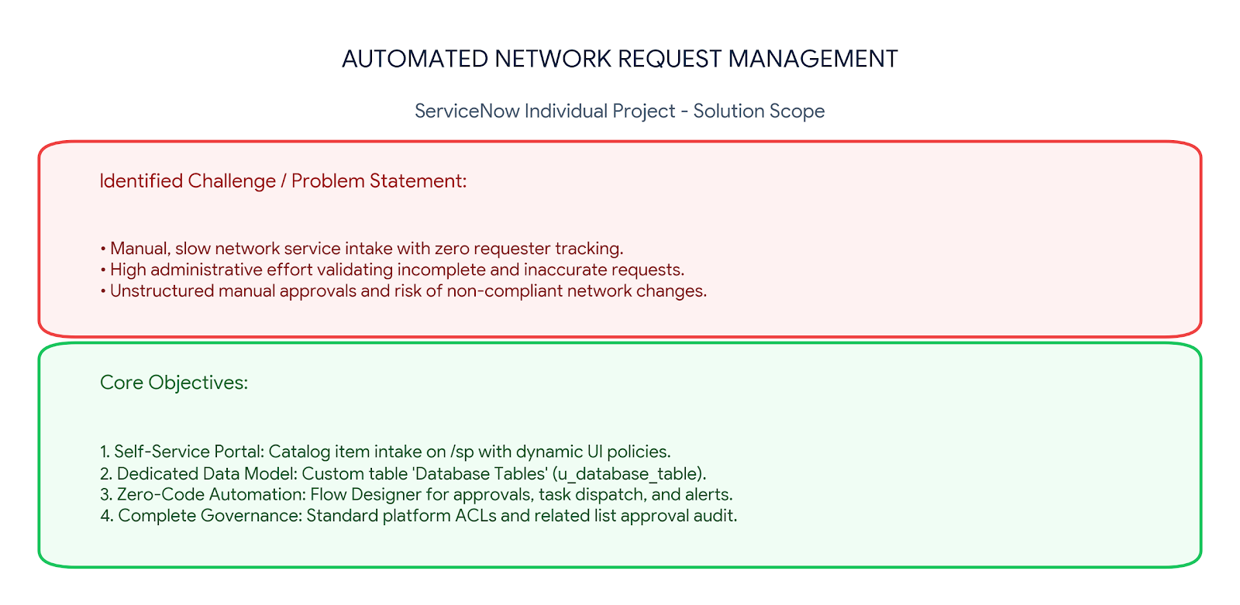

- Problem Statement: Manual, paper-based, or email-driven network request submissions cause long turnaround times, lack real-time visibility, and create repetitive triage work for network engineers.
- Data Architecture: Store all captured request details in a dedicated custom table named Database Tables (u_database_table) with unique Auto-Numbering.
- Form Automation: Implement dynamic Catalog UI Policies to reveal context-sensitive fields only when needed (e.g., Existing ID, Please Specify).
- Workflow Engine: Leverage Flow Designer for automated approval routing, milestone status updates, network task dispatch, and requester notifications without writing custom scripts.

Step-2: Brainstorm, Idea Listing and Grouping

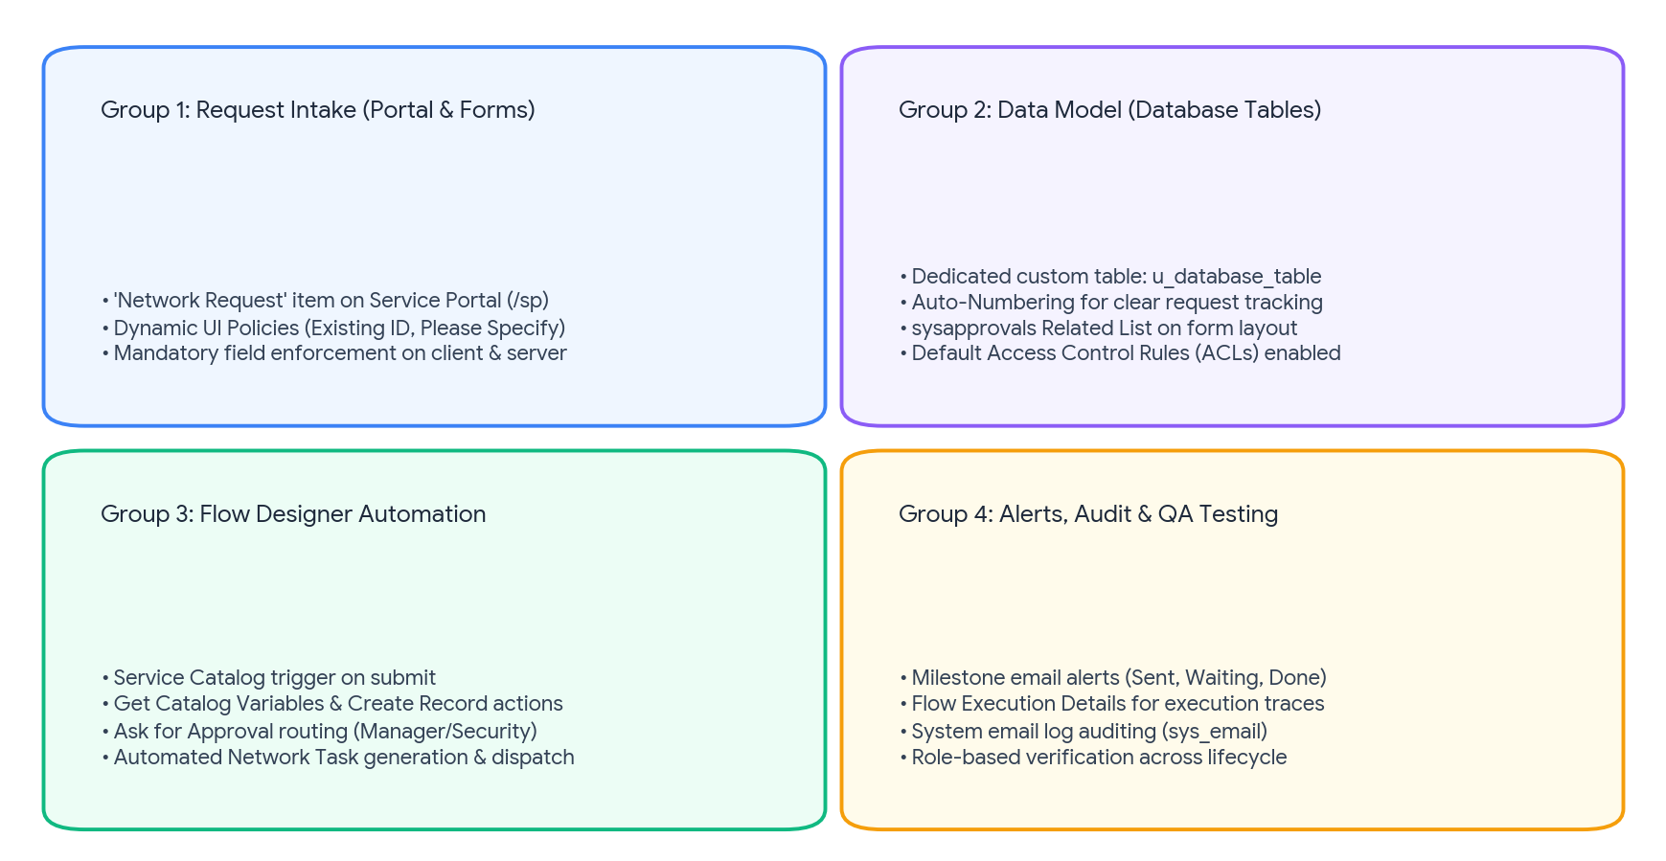

- Group 1 (Request Intake & UI): Service Portal (/sp) self-service item with mandatory validation and dynamic UI Policies.
- Group 2 (Data Architecture): Custom table Database Tables (u_database_table), default ACLs, and Related List for approval records.
- Group 3 (Process Automation): Flow Designer actions (Get Variables, Create Record, Ask for Approval, Update Record) and fulfillment task dispatch.
- Group 4 (Governance & Logs): Multi-stage email notifications, Flow Execution logs, and role-based verification across the request lifecycle.

Step-3: Idea Prioritization
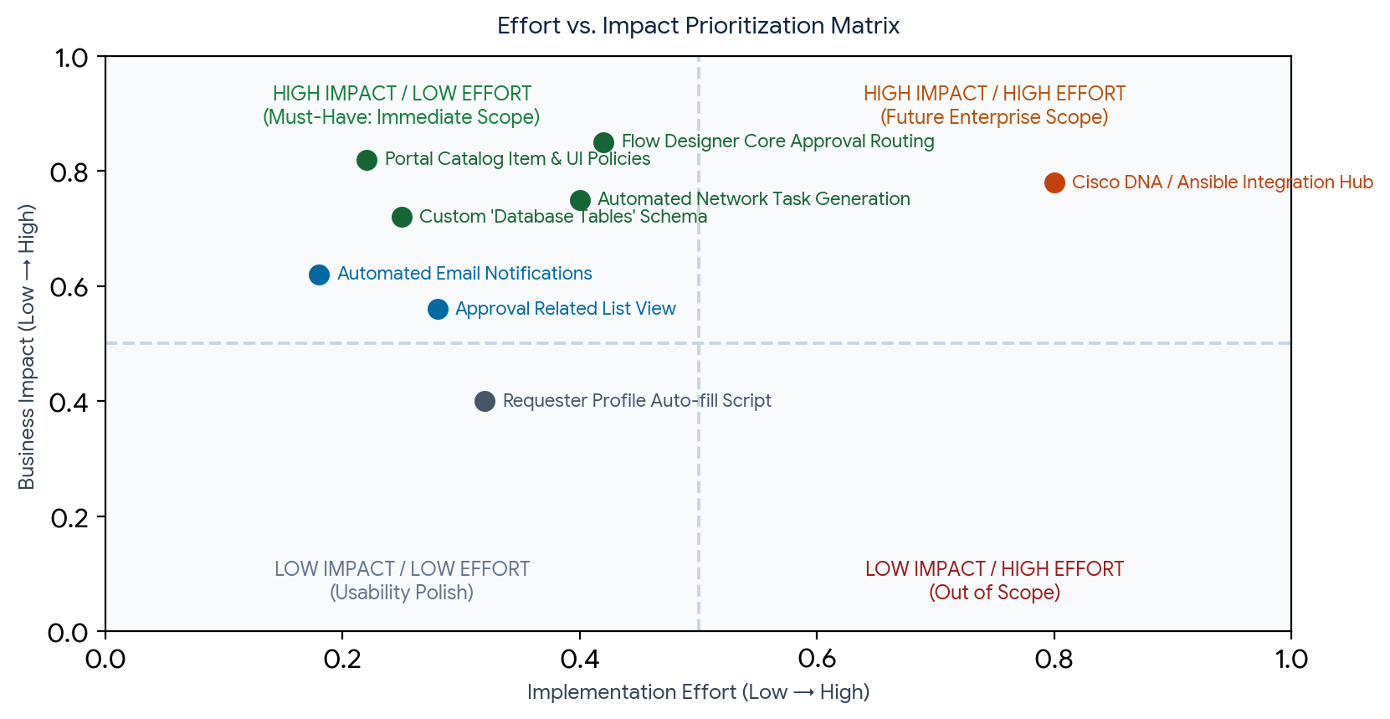

Priority Tier | Implementation Item | Impact | Scope Decision
Must Have (P1) | Service Portal Catalog item with dynamic Catalog UI Policies | High | Implemented immediately
Must Have (P1) | Custom table Database Tables (u_database_table) with Auto-Numbering | High | Implemented immediately
Must Have (P1) | Flow Designer logic: dynamic approvals & network task generation | High | Implemented immediately
Should Have (P2) | Automated multi-stage email notifications (Requester & Approver) | High | Implemented in workflow
Should Have (P2) | Approval Request Related List added to Database Tables form | Medium | Implemented on form layout
Could Have (P3) | Auto-populating requester profile details via client script | Medium | Included as phase polish
Won't Have (P4) | External orchestrator integration (Cisco DNA Center / Ansible) | High | Future enterprise roadmap

